Project Executable Files

Date | 29 September
Team ID | 6ab2aa7b1266c775575a9cb4
Project Name | Farm Management System
Maximum Marks | 3 Marks

Project Executable Files
This section requires submission of all executable and deployable files for your project. Ensure all files are properly organized, named, and uploaded to the specified submission platform. The evaluator must be able to run or deploy your solution using the provided files and instructions.

Step 1: Submission Checklist

S.No | Item to Submit |  | Submitted  No / NA) | (Yes | /
1 | Complete source code (all files and folders) |  | Yes salesforce conventional meta data
2 | README / Setup Guide (instructions to run the project) |  | yes
3 | requirements.txt / package.json / dependency file |  | NA
4 | Database schema / seed files (if applicable) |  | NA
5 | Environment configuration file (.env.example similar) | or | NA
6 | Deployed application URL (if hosted) |  | Home | Salesforce
7 | APK / Executable binary (if applicable for mobile/desktop apps) |  | NA
8 | Dockerfile / Containerization config (if applicable) |  | NA
9 | Test files and test results |  | yes
10 | Demo video or walkthrough (if required) |  | https://drive.google.com/file/d/1s-_COzFWUfl8VZWApoSjYFnxM4dvjL_4/view?usp=drivesdk

Step 2: File / Folder Structure
Provide an overview of your project's file and folder structure below:

Farm Management System

├── Project Documentation
│ └── Farm Management System Project Document
├── Salesforce
│ ├── Farmers
│ ├── Farms
│ ├── Crops
│ ├── Buyers
│ ├── Reports
│ └── Dashboards
└── Test Cases

Step 3: Deployment / Access Details

Field | Details
Hosted / Deployed URL | https://orgfarm-a16421c053-dev-ed.develop.lightning.force.com/lightning/o/DevopsActivityLog/list?filterName=__Recent
Login Credentials  (Demo) | pavithragnanavel2006.524def497c47@agentforce.com  Password: pavithra@08
Platform / Hosting  Provider | Salesforce environment
Repository Link | https://github.com/pavithragnanavel2006-gif/salesforce-project-admin
Demo Video Link | https://drive.google.com/file/d/1s-_COzFWUfl8VZWApoSjYFnxM4dvjL_4/view?usp=drivesdk

Step 4: Run Instructions
Provide clear, step-by-step instructions for the evaluator to run your project locally:

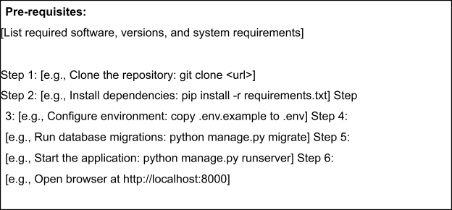

Step 5: Known Issues / Limitations

S.No | Known Issue / Limitation | Workaround / Status
1 | The system depends on the Salesforce environment for access. | Access through the configured Salesforce environment
2 | Reports display information based on the records entered into the system. | Add and maintain accurate Farmer, Crop and Buyer records.
3 |  | Additional modules can be added in future versions.
  The current project focuses on core Farmer, Crops and Buyers management.

